

|  |  |  |  |
| --- | --- | --- | --- |
| Farah ismail | 20190618 | Electric power and Energy engineer | Far20190618@std.psut.edu.jo |
| Issam Aldajani | 20170230 | Electric power and Energy engineer | Iss20170230@std.psut.edu.jo |
| Ahmad aljadoo | 20180811 | Network engineer | Ahm20180811@std.psut.edu.jo |

**Abstract**

In this project we worked as a team to create and develop a non-trivial embedded system or device that performs some useful function, which is a smart city which consist of three main parts. The smart car, the smart streetlight and smart traffic light.

Using pic 16f877a microcontroller we are trying to develop our embedded system, starting the process by coding the pic, testing it then connecting our components together. More details will be included in this report.

**Introduction**

Auto intensity of street lights and smart traffic systems are two important technologies that are being implemented in cities around the world to improve safety and energy efficiency. The auto intensity feature allows street lights to adjust their brightness based on the level of ambient light, reducing energy consumption and light pollution. Smart traffic systems, on the other hand, use sensors and cameras to gather data on traffic patterns, which can be used to optimize traffic flow and reduce congestion. Together, these technologies have the potential to make our cities safer, more efficient, and more sustainable.

In this project we are trying to set our knowledge in embedded system to create our smart city to make the street more flexible and fancier our main idea consist of three main parts, first of all smart car this car consists of two dc motors , h-bridge and car kit ,secondly Smart street light which consist of LDR ,LED and infrared sensor and in the last part of the project we have the smart traffic light which consist of ultrasonic sensor which detects the vehicle movement to decide whether the green light or red light is on when a vehicle exist.

**Smart streetlight**: Streetlight is switched on depending on sunlight intensity on the LDR which is low resistance in light, and high resistance in dark. When in dark, the RTC starts working. The controller checks the peak where there is no traffic and turns off the lights. When there is a vehicle on the road the PIR detects it and gives an indication to the microcontroller to switch on the lights on, after a delay of a few minutes the light is off again.

Controls for street lighting lower energy use and carbon dioxide emissions. By selectively dimming metropolitan areas, roadways, or specific lighting fixtures, over-lighting can be avoided. Consequently, effective and long-lasting energy savings can be achieved by using the smart street lighting system.

**Speed controlled car**: DC motor speed control using PWM we can achieve a required speed by changing the duty cycle of the PMW increasing the on –time and decreasing the off-time while both are having the same frequencies by this method, we can control the speed. We are using the timer and switch to generate the signal.

**Traffic sensor**: Every traffic light signal contains a sensor or a timer to assist it control traffic. Traffic is typically controlled by traffic lights that have timers in large cities where cars constantly cross busy junctions. On the other hand, traffic signal sensors (detectors) are typically favored in suburban areas and on county roads because they can efficiently regulate the erratic traffic flow as well as identify approaching vehicles, a buildup of vehicles at an intersection, and vehicles entering turn lanes. Traffic sensor consists of IR sensor to get the indication of the vehicle presence so that the traffic turns green else its red.

**Design**

In our design we needed to take some value into consideration. Calculating some values such as the resistance used in current limiting resistors, pull down resistors LDR value in dark and light and We used H-bridge to control speed Our design require that the software design should be written without using the libraries using c language, the car must be able to move forward backward and in two different speeds, the car made of light and tough material so the car should not exceed 1.3kg to 1.5kg weight, able to move without breaking. For the traffic light the traffic should be able to turn on and off depending on the sensor value and so the smart streetlight depending on the LDR

sensor and devices used:

IR sensor is an electronic device, that emits the light to sense some object of the surroundings

Ultrasonic sensors are electronic devices that calculate the target’s distance by emission of ultrasonic sound waves and convert those waves into electrical signals

Joystick is a device which changes the resistance value which is converted to voltage as pic needs

Which works as an anlage value needs to ATD port input DC motor need 9v to turn on

**Mechanical design**

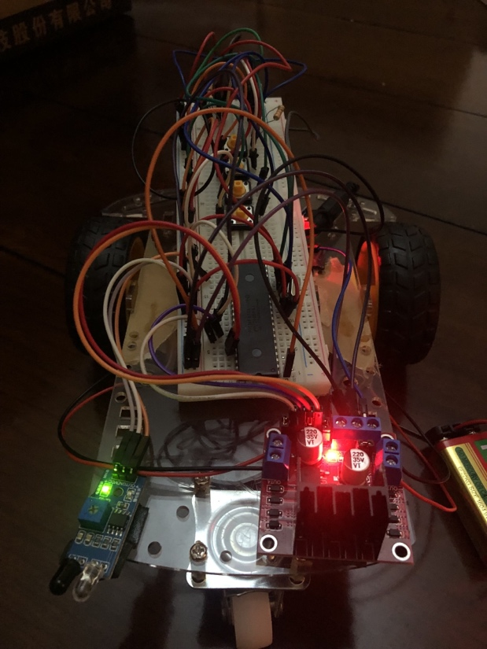

Figure1: car structure

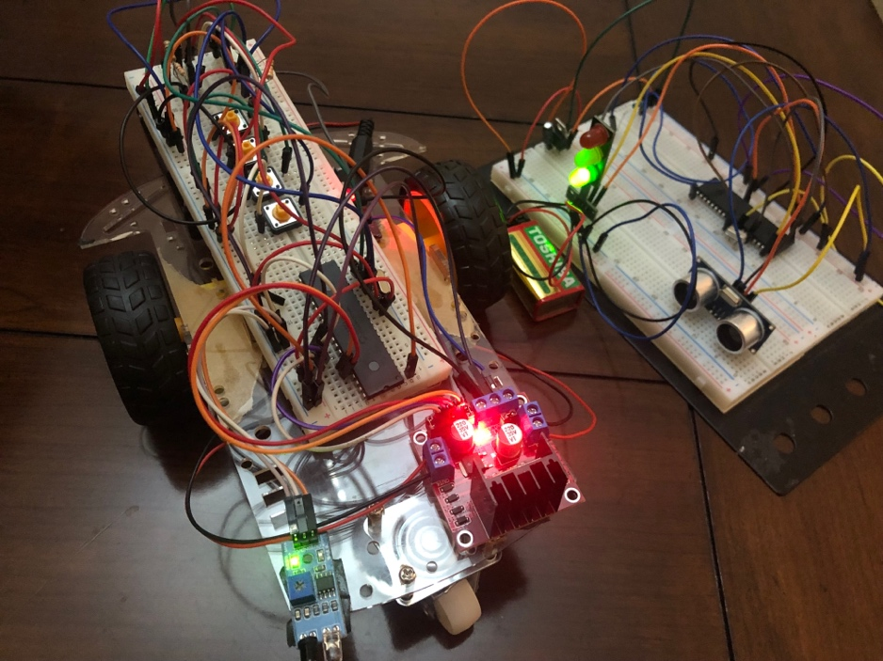

Figure2: car structure and traffic light

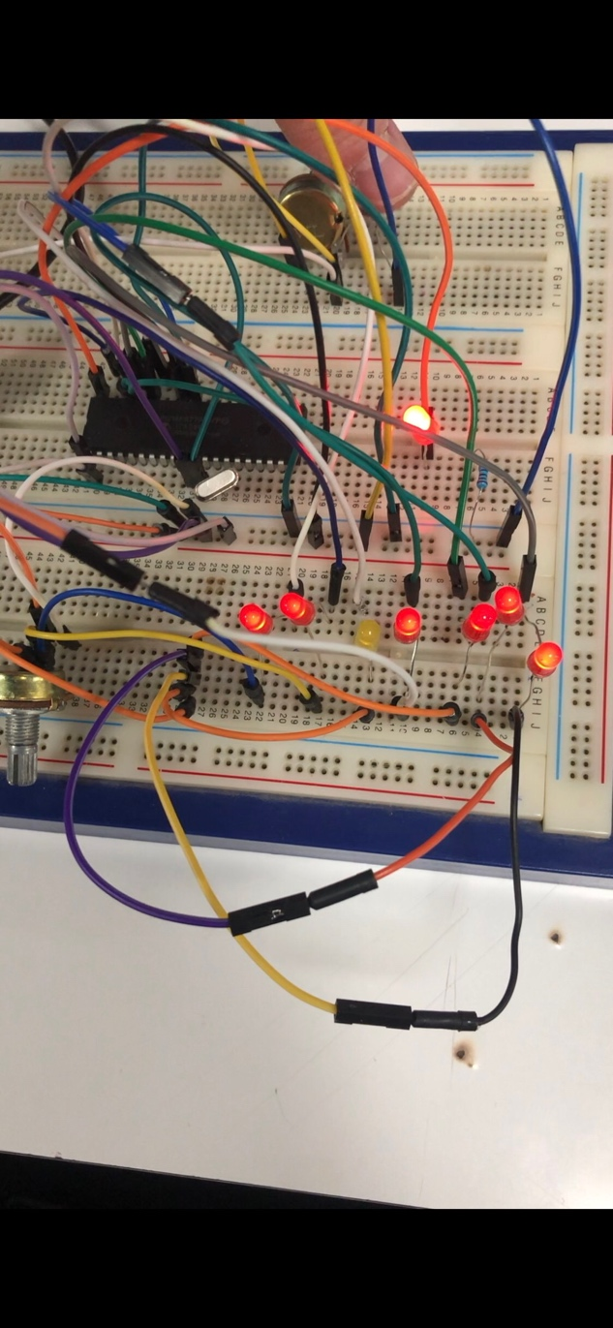

Figure3: streetlight

**Electrical design**

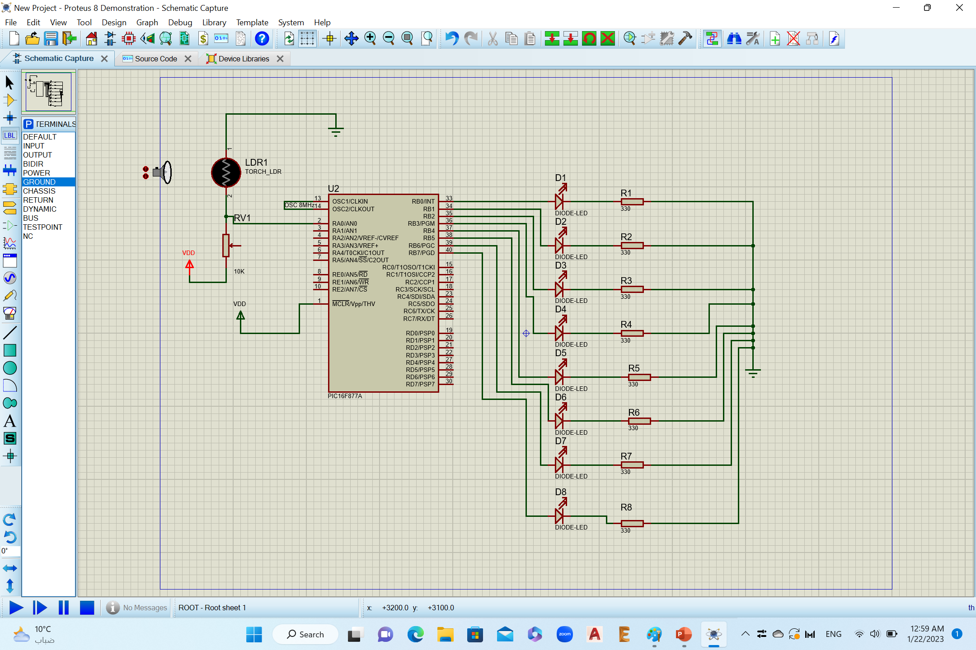

Figure5: electric design of the street light

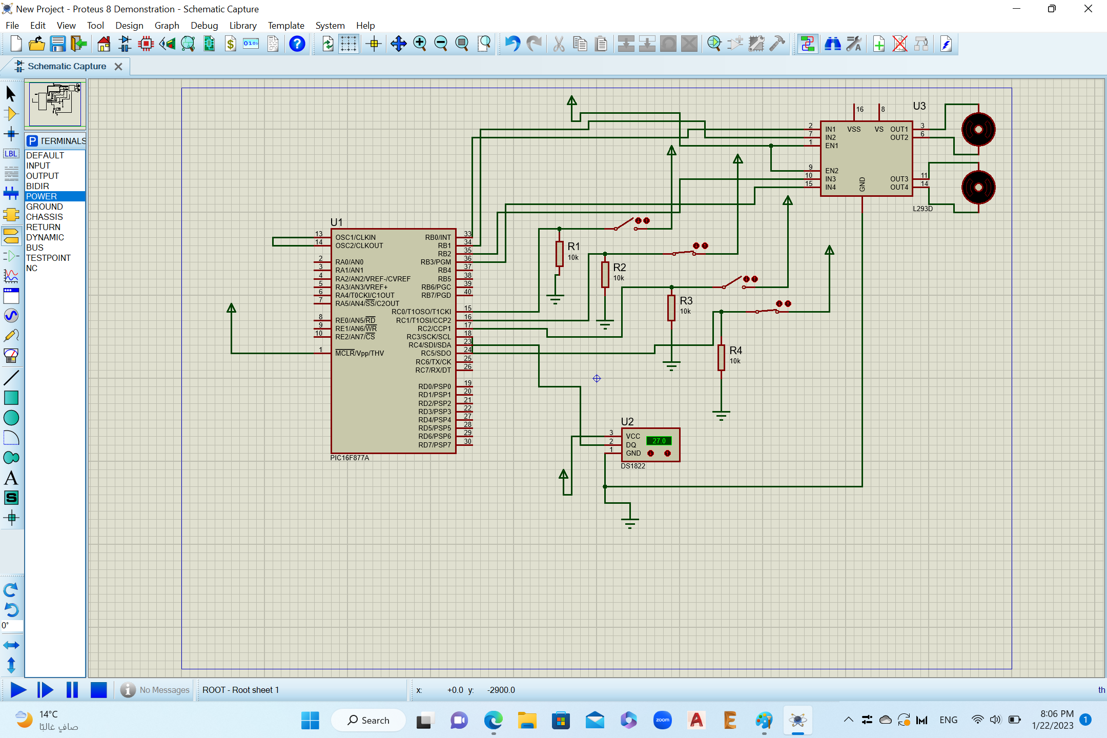

Figure 6: electric design of the motor based on push buttons

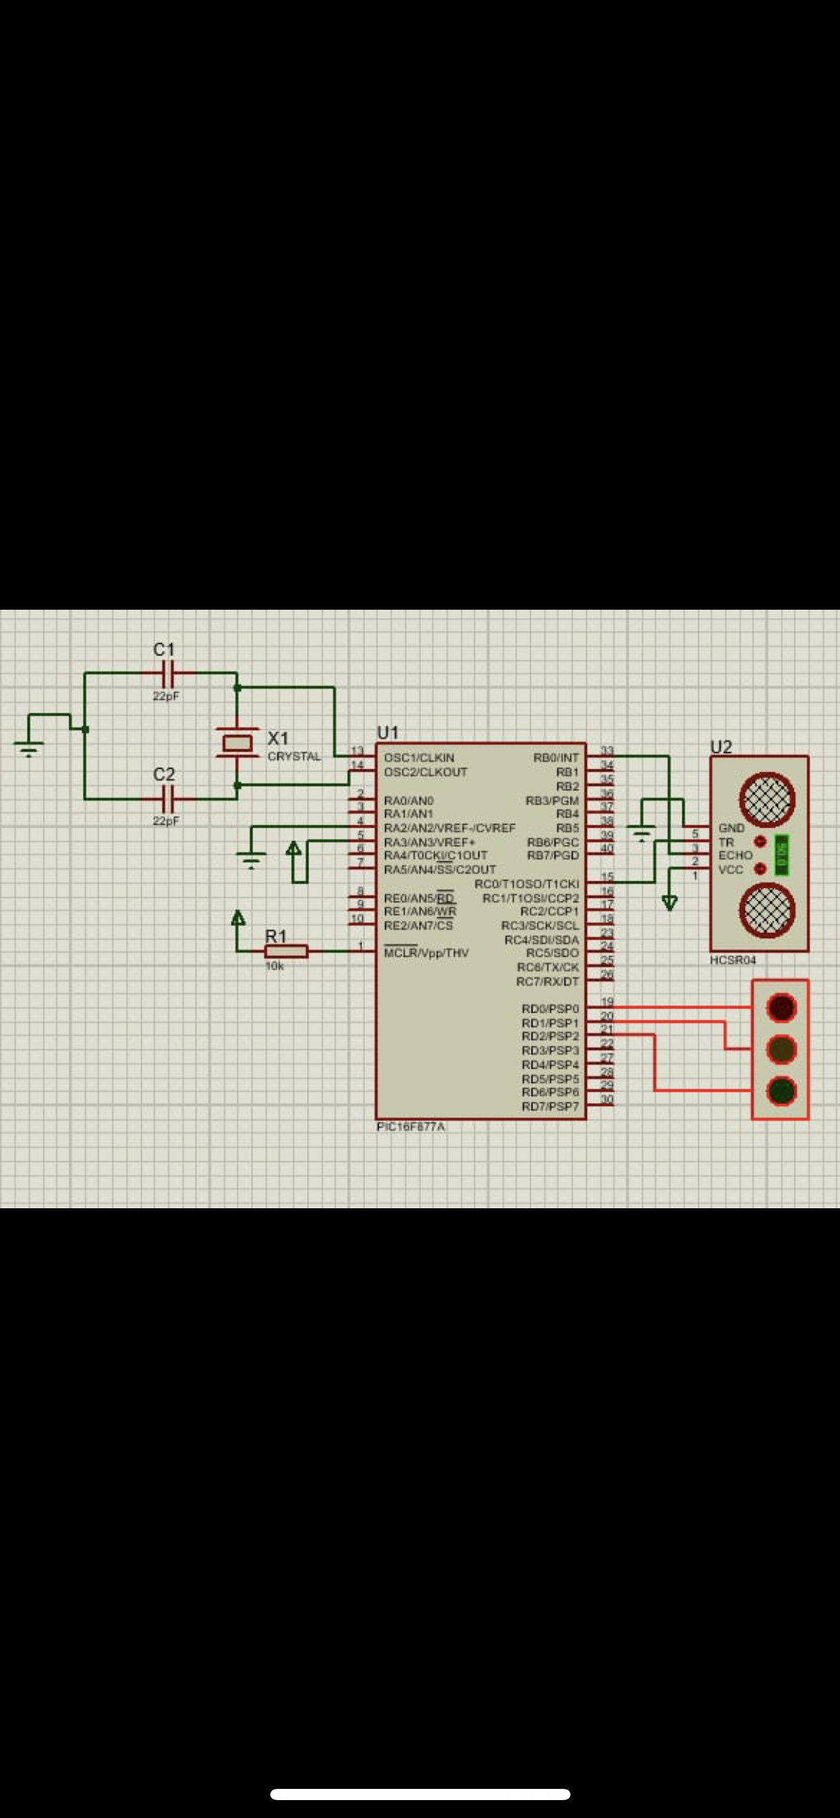

Figure7: electric design of traffic light

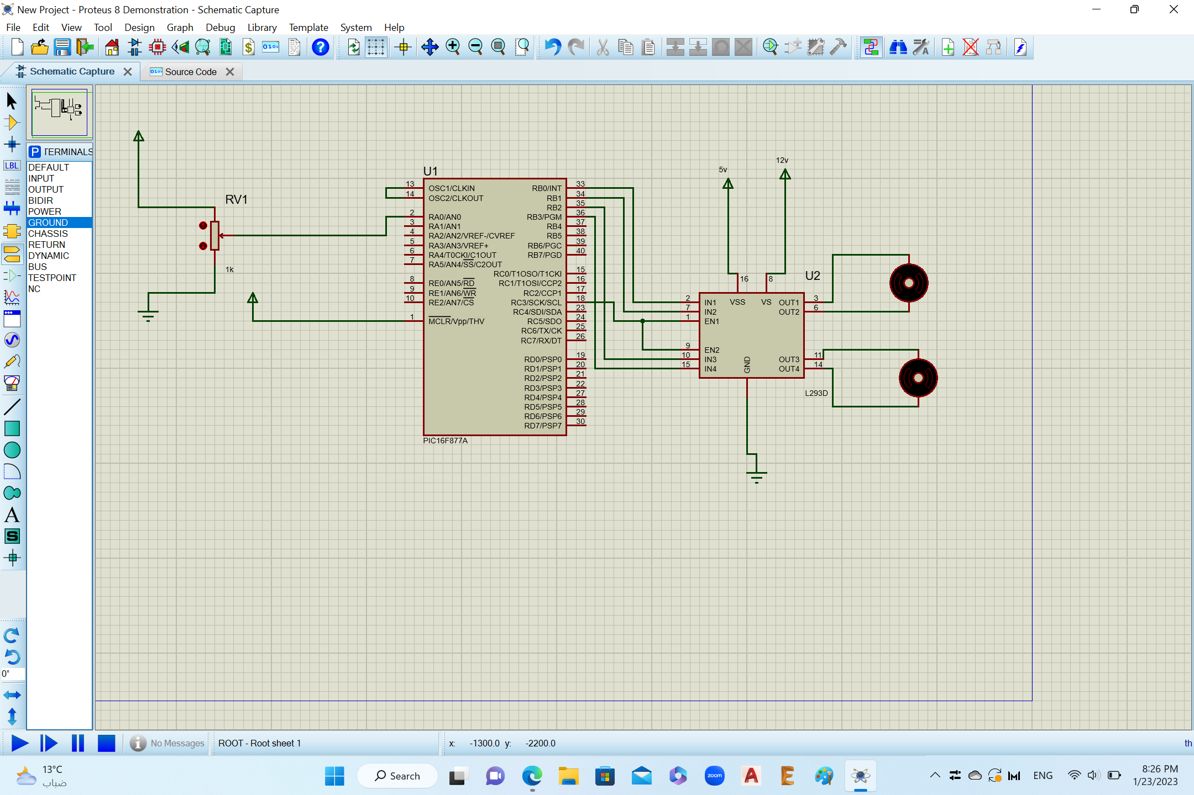

Figure8: electric design of Joystick motor controlled (Variable resistor indicates the joystick)

**Software design**

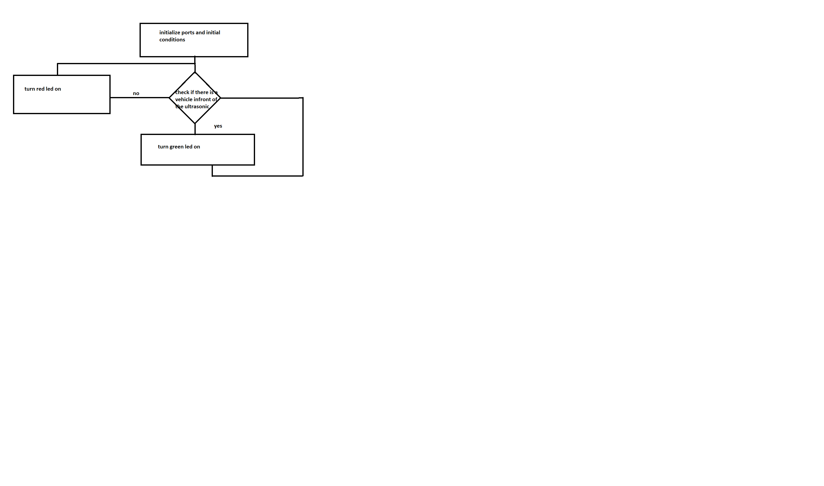

Figure9: traffic flow chart

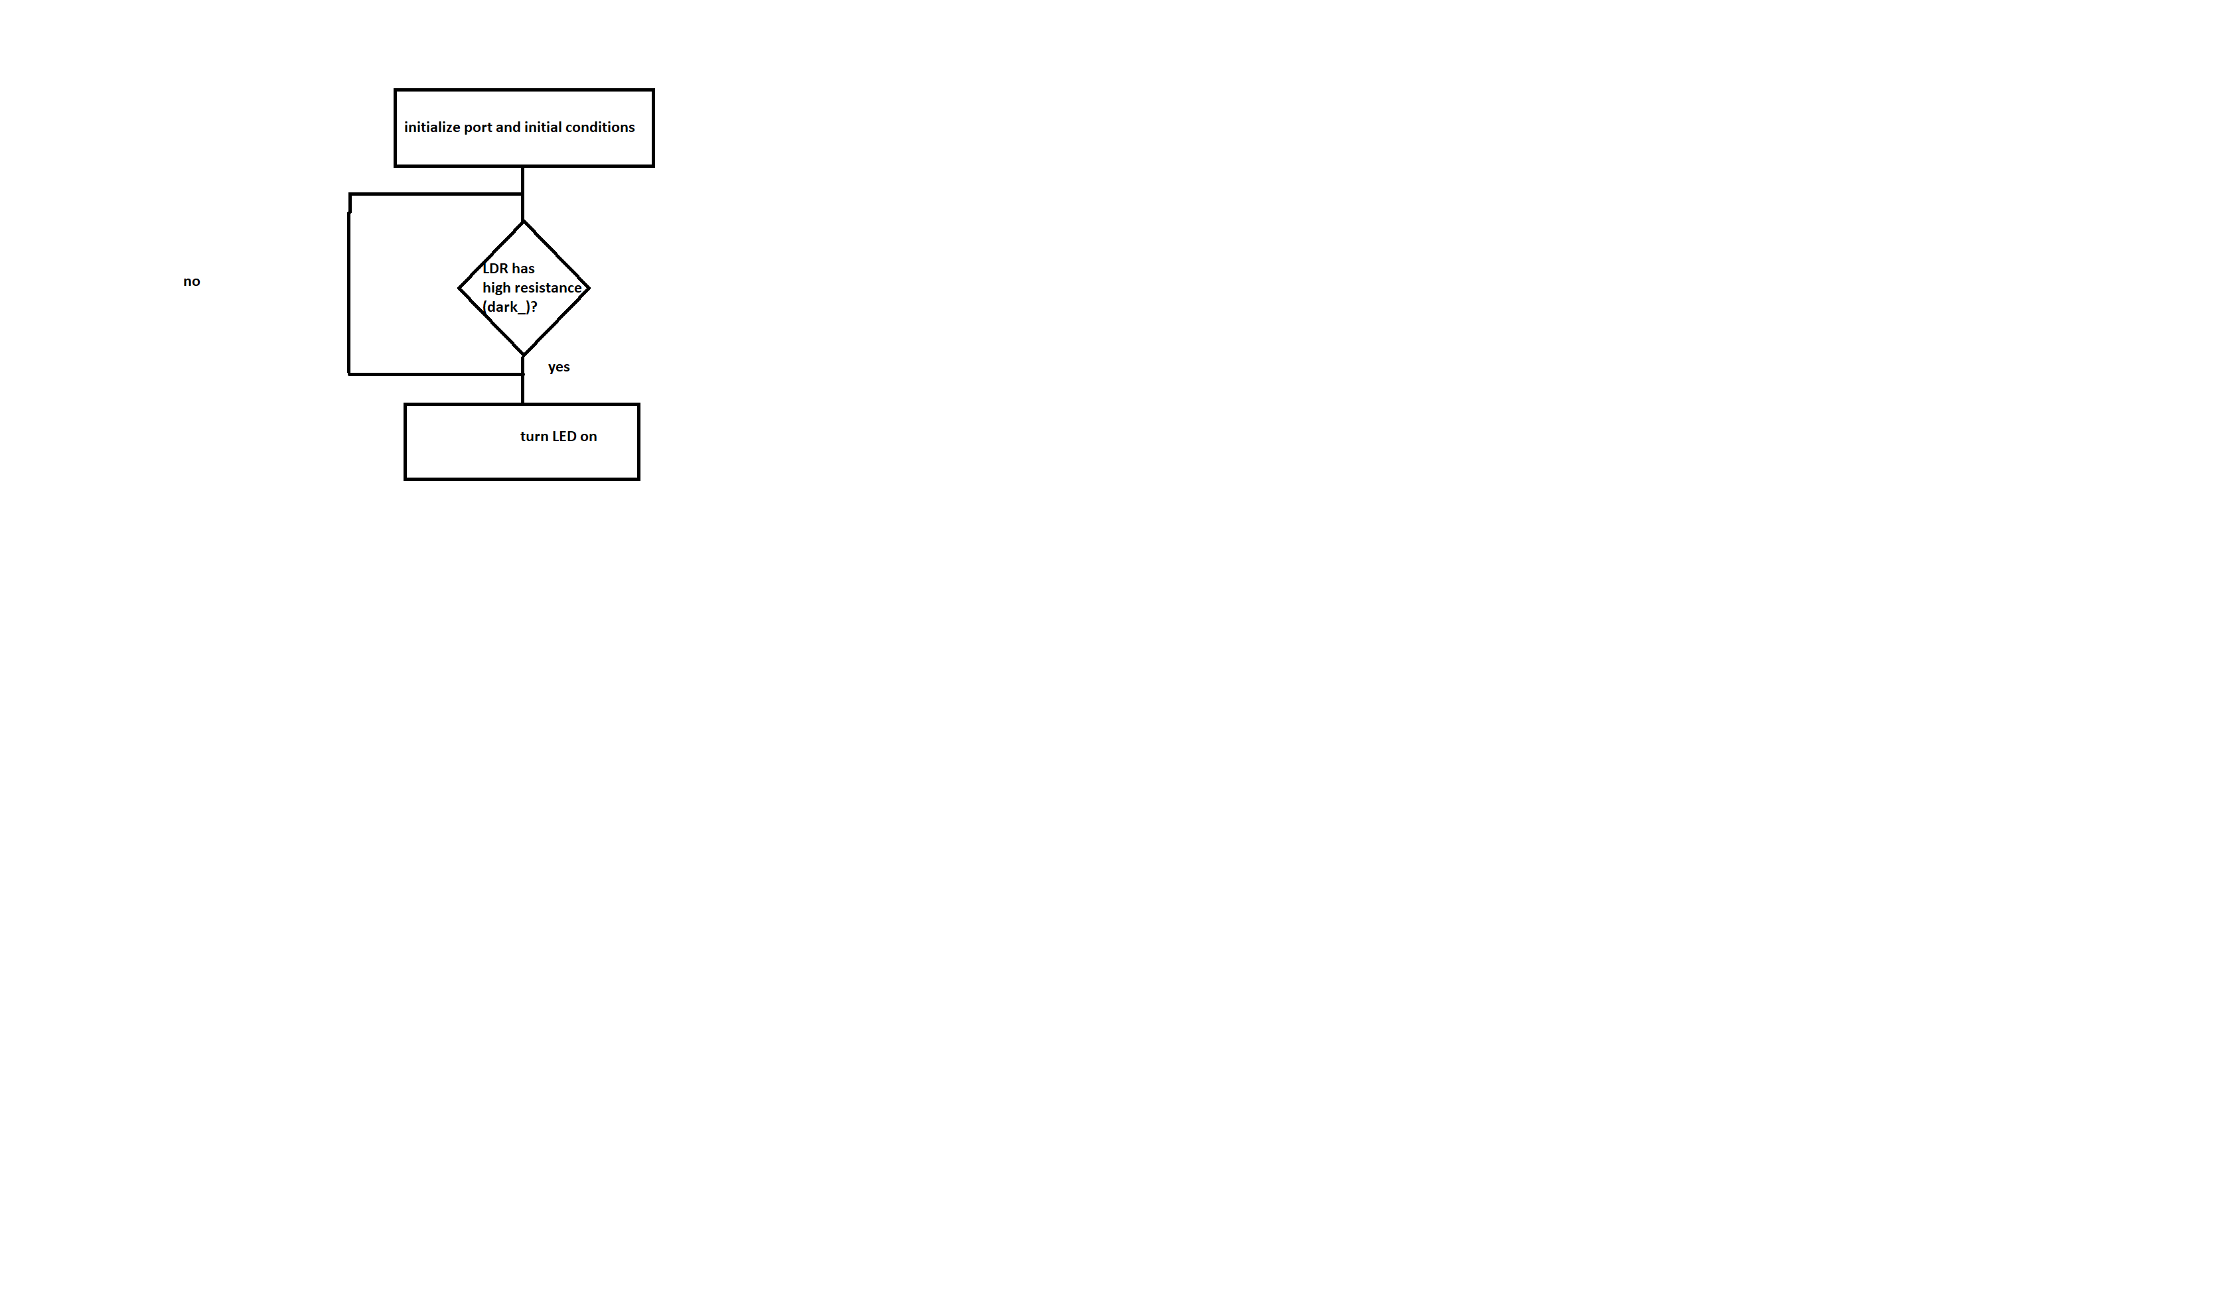

Figure 10: flow chart of the streetlight

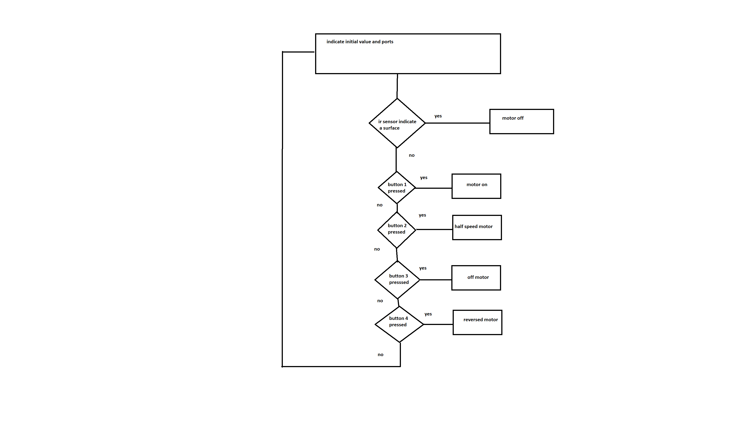

Figure11: flow chart of the car based on push button

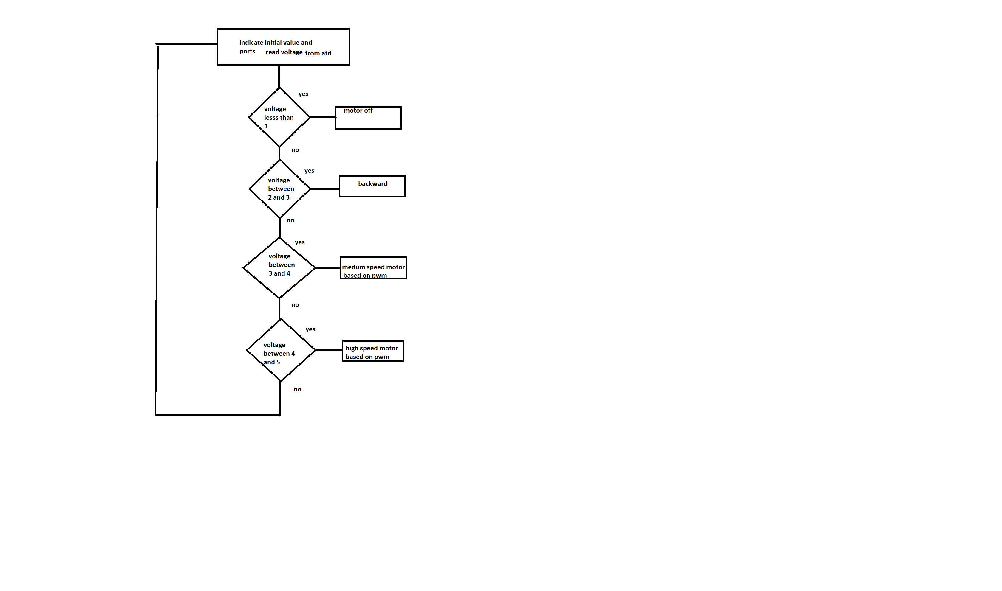

Figure12: flow chart of the car based on joystick

**Problems and recommendations**

In our smart car software, it was concluded that using the pulse width modulation as an input source and enabling the H-bridge input to switch direction is better to use and more practical in our case to save a port .Also we had an issue to stop the car before crashing to an object so we added an Infrared sensor to detect the object and so it stops automatically.

In the smart streetlight we used the LDR which out puts a resistance value. It was concluded that the voltage divider is a solution to convert the resistance value of the LDR to voltage so that the microcontroller can use it as it only recognizes voltage.

**Conclusion**

In this project we determined that sensor actuator and the components used to make our circuit are used in specific manner some sensors uses analog to digital converter as in the LDR , the LDR value was read as an analog resistance then converted to analog voltage using voltage divider method the pin of the microcontroller uses ATD in the microcontroller peripherals which converter which a convert the analog read to digital value so the microcontroller can use.

Some other sensors can be directly connected through the micro controller as their output is a digital value. Motors used in the smart car needed an h bridge as a driver to provide the output in different directions